Software Requirement Specification

University of Maryland Global Campus

SWEN 670 – Team A

Fall Semester

Version 1.2

October 29, 2022

Revision History

|  |  |  |  |
| --- | --- | --- | --- |
| Date | Version | Description | Author |
| 9/03/2022 | 1.0 | Initial PMP Submission | Team A |
| 9/17/2022 | 1.1 | Added updates post Milestone 1 submission, including updates to use cases, and revised use cases to better match new UI and removed vocal interface since it is going to Team B | Team A |
| 10/29/2022 | 1.2 | Post-development updates | Team A |

**Table of Contents**

1. Introduction 1

1.1 Purpose 1

1.2 Project Documents 1

1.3 Scope 2

1.4 Definitions, Acronyms and Abbreviations 3

1.5 References 3

1.6 Overview 3

2. Overall Description 3

2.1 Use-Case Model Survey 4

2.1.1 Use Case Diagrams 5

2.2 Assumptions and Dependencies 12

2.2.1 Assumptions 12

2.2.2 Dependencies 12

3. Specific Requirements 12

3.1 Use-Case Reports 12

3.1.1 Use Case Name: Viewing Sender/Keyword Notifications List Visually 12

3.1.2 Use Case Name: Adding Sender/Keyword to Notify for Visually 15

3.1.3 Use Case Name: Deleting Sender/Keyword to Notify for Visually 19

3.1.4 Use Case Name: Receiving Sender/Keyword Notifications 20

3.1.5 Use Case Name: Sending Barcode and Link Data to USPS 21

3.1.6 Use Case Name: Track and Report Consumer Data 22

3.1.7 Use Case Name: Open resulting mail piece from search 22

3.1.8 Use Case Name: Adding Senders to the Notification List via Personal Assistant 23

3.1.9 Use Case Name: Searching for Emails Via Personal Assistant 24

i. Use Case Name: Opening Daily Digest Via Personal Assistant 25

3.1.10 Use Case Name: Launching Application via Personal Assistant 25

3.1.11 Use Case Name: Call or text a phone number in an email or digest visually. 26

3.1.12 Use Case Name: Send an email to an email address in an email or digest visually. 29

3.1.13 Use Case Name: Display links as clickable hyperlinks in retrieved email/digest 30

3.1.14 Use Case Name: Displaying barcodes or QR codes as clickable hyperlinks in email. 31

3.2 Supplementary Requirements 32

3.3 Non-functional Requirements 32

4. Supporting Information 32

# Introduction

The United States Postal Service (USPS) is an agency that transports mail to and from residential customers. To better assist their customers, the USPS offers a free subscription service called Informed Delivery that allows users to receive images of the mail incoming 7 days a week. The service even allows senders of mail items to associate advertisements via their campaign feature, replace black and white images of mail with full color photos, and show packages arriving within the next week as well as outbound.

A third-party application called “Mailspeak” has been developed to assist informed delivery users to better access their mail. To extend the applications functionality, the product owner has requested a set of features that will allow customers to be able to better consume and interact with the Informed Delivery service.

The application is intended to run on mobile devices and will allow voice commands to find mail items as well as notifications to trigger when items are received.

## Purpose

The purpose of this Software Requirements Specification (SRS) document is to describe the requirements that have been committed for the initial release of the Mailspeak mobile application.

Informed Delivery is a service provided by the United States Postal Service (USPS) that allows users to preview their incoming mails and manage package deliveries digitally. Informed delivery also allows you to perform limited actions like receiving USPS tracking updates for your packages, providing delivery instructions, scheduling re-delivery, and setting mail piece reminders. To make Informed Delivery more accessible to people with visual impairments, the product owner has created a mobile application that can read the user's Informed Delivery Daily Digest email from their inbox or mail piece image from their phone's camera and display relevant information.

The product owner has requested additional functionality for the Mailspeak application. Two teams are assigned to develop the new features: Team A and Team B. This SRS describes Team A's implementation requirements.

## Project Documents

This Technical Design Document is part of a set of documents created to aid in developing the USPS Informed Delivery Application and to provide artifacts with vital information for the application’s ongoing support and operation throughout its life cycle.

**The following documents are included in the entire documentation package:**

|  |  |  |  |
| --- | --- | --- | --- |
|  | Document | Version | Date |
| 1 | Project Management Plan (PMP) | 1.2 | 9-17-2022 |
| 2 | Software Requirements Specification (SRS) | 1.2 | 10-29-2022 |
| 3 | Technical Design Document (TDD) | 1.2 | 10-29-2022 |
| 4 | Software Test Plan (STP) | 1.1 | 10-29-2022 |
| 5 | Programmers Guide (PG) | 1.1 | 11-05-2022 |
| 6 | Deployment and Operations (DevOps) | 1.1 | 11-05-2022 |
| 7 | User Guide (UG) | 1.0 | 11-05-2022 |
| 8 | Test Report (TR) | 1.0 | 11-05-2022 |

## Scope

The scope of Team A’s implementation for the USPS Informed Delivery application revolves around seven initial requirements from the customer across four main features. One exception is that the Voice Assistant function will also include Search functionality as developed by Team B.

All accessibility features, including voice input and screen reading, are not within scope of Team A’s requirements. All accessibility features will be covered by Team B’s documentation.

* **Mail View**
  + Open resulting Mail Piece [from search]
  + Call, Email, or send a text message to the sender or contact on command
    - Ensure features in “Do more with your mail” are supported
  + Visit links or barcodes
    - Ensure features in “Do more with your mail” are supported
  + Provide feedback to product owner on the links or barcodes visited
    - Capture Mailer Identification number (MID) ID/Serial and Links visited to provide analytics data to the product owner
* **Notifications behavior**
  + Provide the functionality to set a notification for a keyword that is evaluated against:
    - Image of a physical envelope (most important)
    - Mail piece sender information (secondary)
    - Other text fields (least significant)
  + Type should be system notification; in addition, there should be an in-app version of the notification that persists in case a person dismisses the system notification.
  + Tapping on the system notification or in-app notification should take user to mail message.
* **Internal Feedback**
  + Research cyclic consumer behavior to report to the product owner and their customers
  + Provide a link to terms and conditions and ensure user agreeance.
  + Provide anonymous real-time analytics concerning mail piece IDs in Informed Delivery messages.
* **Voice Assistant**
  + VA1: Integrate with Google Assistant on mobile devices. Siri has been removed as a requirement.
  + Ensure that interplay between native voice assistant, in-app voice control, and chatbot is intuitive.

The scope of the functions that provide data to USPS will, for the duration of this project, be a simulated Application Programming Interface (API) developed by the project team. This simulated API will not actually communicate with any actual USPS servers but will provide as a point of insertion should this communication need to be fully implemented.

## Definitions, Acronyms and Abbreviations

This document contains several words that pertain to the application that is being developed. To give more clarity, however, the following terminology relating to the application is defined:

* SRS – Software Requirement Specification
* USPS – United States Postal Service
* iOS – iPhone Operating System
* IDE – Integrated Development Environment
* UML – Unified Modeling Language
* API – Application Programming Interface

## References

Assadullah, M. (2022). Project Scope. Retrieved August 30, 2022 from <https://learn.umgc.edu/d2l/le/news/718165/2732428/view>

“Close”. (n.d) Google Material Symbols and Icons. Retrieved August 30, 2022 from <https://fonts.google.com/icons>

Google. (2020). *YouTube Music Phase 5 Software Requirements Specification* [DOCX].

“Mic”. (n.d). Google Material Symbols and Icons. Retrieved August 30, 2022, from <https://fonts.google.com/icons>

## Overview

There are two parts to this Software Requirement Specification (SRS): the Overall Description and the Specific Requirement. The Specific Requirements will go into more detail about the modules that this document will cover, while the Overall Description will give an overview of the requirements.

# Overall Description

USPS Informed Delivery currently has an application that can perform various functions. These include checking a customer's email for USPS informed delivery mail on a specified date, and filtering by latest or unread email. The application can dictate emails and also accept voice commands. Additionally, there is a mail scanner which can use the mobile device to take an image. The application has settings which can be controlled by the user to determine what information will be displayed.

USPS would like to add numerous enhancements to the existing application. These include four main categories.

1. The first category includes items associated with email. USPS would like to provide functionality to open an email from a search term, adding the ability to call, email, or send text message to the email sender, visit links or barcodes associated with each email and mail item, and provide feedback to USPS on the links or barcodes visited.
2. The second category includes giving the user the ability to be notified about incoming mail from a specified sender.
3. The third category includes providing cyclic consumer behavior within the application to report to USPS and its customers.
4. The fourth category includes integrating the voice assistant with Google Assistant and Apple Siri.

## Use-Case Model Survey

There are 6 Use Cases that make up the requirements for the specified functionality. Detailed Use Cases are identified in section 3.

|  |  |
| --- | --- |
| **Use Case** | **Description** |
| 1. Feedback for USPS on links or barcodes visited | Report light data analytics to USPS. |
| 1. Lookout for mail from someone | Know when mail comes from a specified sender or keyword. |
| 1. Integrate With Google Assistant | Use voice-controlled assistance to help navigate the app. |
| 1. Visit links or barcodes | App redirects you to pages to view content behind link or barcode. |
| 1. Call, email, text message to sender or contact on command | Clicking on email from search results automatically directs you to the email. |
| 1. Open resulting email from search | Clicking on email from search results automatically directs you to the email. |

### Use Case Diagrams

#### Application Feedback Enhancements

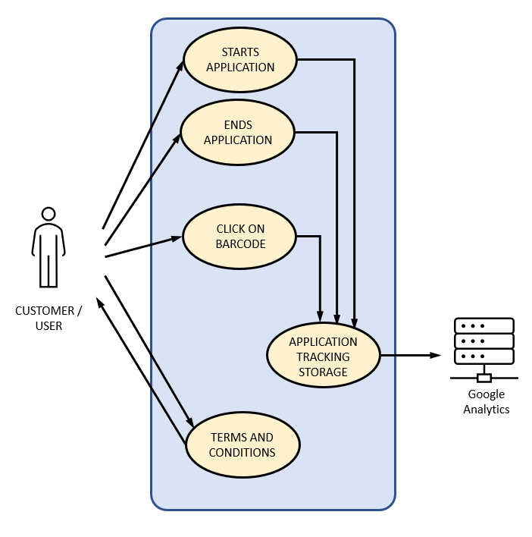

Figure 2 – Application Feedback Enhancement

Description:

This Use Case diagram describes the functionality for providing the USPS with feedback concerning links or barcodes visited and also cyclic consumer behavior.

Use Cases:

* Track data on link or barcode visited
* Track data on customer application usage for marketing research.
* Track with Google Analytics.

Primary Actor:

Customer – user of the application.

Supporting Actors:

Google Analytics online server – entity to transmit the collected data to.

Stakeholders and Interests:

Application marketing customers interested in usefulness of targeted advertising.

Pre-Conditions:

Customer currently has an Informed Delivery email account.

Post Conditions:

Customer successfully downloaded the application and agreed to the terms of service.

Minimal Guarantee:

Tracking data will be available to the product owner when the customer agrees to terms of service and uses the application.

Main Success Scenario

1. Customer installs application and accepts terms of service.
2. Customer uses application and interacts with links, barcodes, and other internal features.

#### Lookout for USPS mail piece from someone

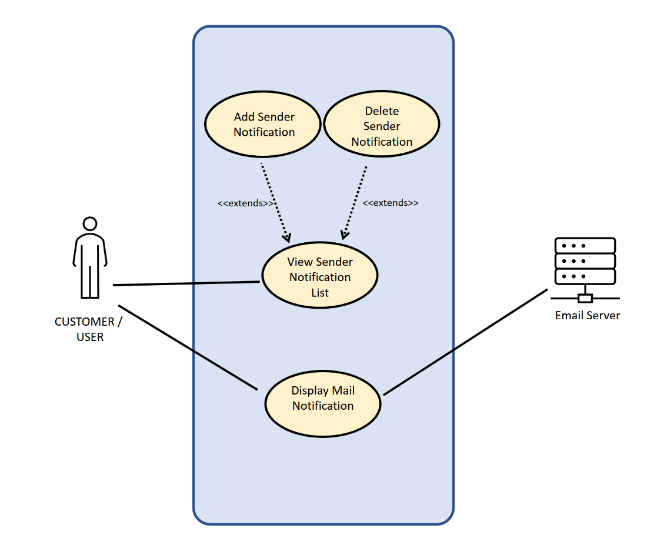

**Description:**

This Use Case diagram describes the functionality for allowing the user to get notifications when mail arrives for a specified Sender or keyword.

**Use Cases:**

* Viewing Sender/Keyword Notifications List Visually
* Adding Sender/Keyword to Notify for Visually
* Deleting Sender/Keyword to Notify for Visually
* Receiving Sender/Keyword Notifications

**Primary Actor:**

Customer – user of the application.

**Supporting Actors:**

Mail Server – The email server that sends email messages.

**Stakeholders and Interests:**

The Customer who wants to get notifications.

**Pre-Conditions:**

Customer currently has an Informed Delivery email account.

**Post Conditions:**

The customer will receive notifications for any mail arriving with a sender in the sender notifications list.

**Minimal Guarantee:**

The user will be able to add notifications for specified senders/keywords, delete notifications for specified senders/keywords, view the list of senders/keywords that they are getting notifications for and receive notifications when mail arrives for a sender/keyword in the list of senders/keywords.

**Main Success Scenario**

1. Customers can add a sender/keyword they would like to be notified of.
2. Customers can delete a sender/keyword from the list if they would not like to be notified.
3. Customers can view a list of senders/keywords that will display notifications if a piece of mail arrives for them.
4. Customers will receive a system notification if mail arrives from a sender or contains a keyword in the notifications list.
5. Customers can select notifications which will allow them to view the mail piece immediately.

#### Integrate With Google Assistant

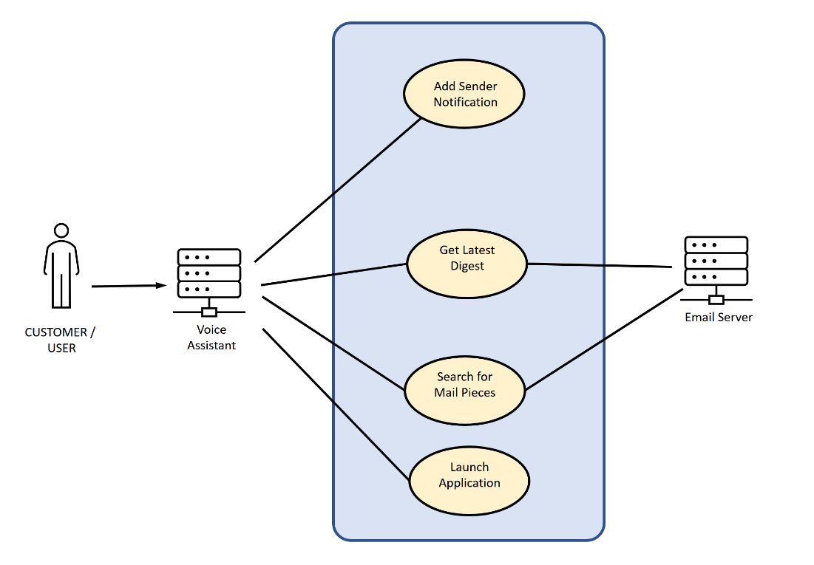

**Description:**

This Use Case diagram describes the functionality for allowing personal assistants such as Google Assistant and Siri to interact with the application and perform basic application functions.

**Use Cases:**

* Searching for Emails Via Personal Assistant
* Adding Senders/Keywords to the Notification List via Personal Assistant
* Launching Application via Personal Assistant
* Opening the Daily Digest via Personal Assistant.

**Primary Actor:**

Customer – user of the application.

**Supporting Actors:**

Personal Assistant– The application that the user will be directing commands through.

**Stakeholders and Interests:**

The Customer

**Pre-Conditions:**

Customer currently has an Informed Delivery email account.

**Post Conditions:**

The user will be able to interact with the application via a personal assistant application.

**Minimal Guarantee:**

The user can search for emails via keywords by using the personal assistant. The user will also be able to add keywords from the senders and keywords list that will notify them if mail comes in with those keywords and senders. The user will be able to launch the application from a personal assistant. The user will also be able to open the daily digest via personal assistant.

**Main Success Scenario**

1. Customers can launch the application via a personal assistant.
2. Customers can add senders and keywords to the notification list via a personal assistant.
3. Customers can Search for emails via keyword via a personal assistant.
4. Customers can open their daily digest via personal assistant.

#### Visit links or barcodes

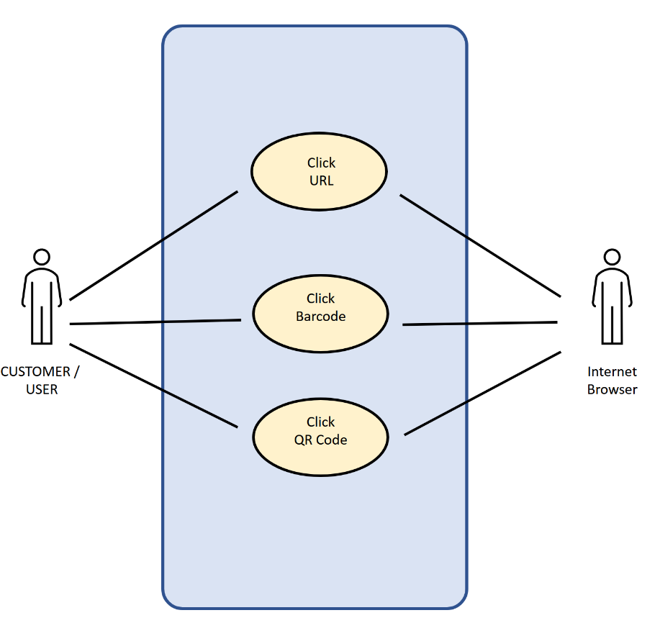

**Description:**

This Use Case diagram describes the functionality for allowing for the user to interact with recognized URL addresses, barcodes, and QR codes in order to follow those through to their destinations.

**Use Cases:**

* Display links as clickable hyperlinks in retrieved email
* Displaying barcodes or QR codes as clickable hyperlinks in retrieved email

**Primary Actor:**

Customer – user of the application.

**Supporting Actors:**

Personal Assistant– The application that the user will be directing commands through.

**Stakeholders and Interests:**

The Customer

**Pre-Conditions:**

Customer is signed up for Informed Delivery.

**Post Conditions:**

The URL destination is accessible by the user’s web browser.

**Minimal Guarantee:**

The application will make every attempt to recognize any URL, barcode, or QR code content and display those items in the Informed Delivery digest email messages as clickable links.

**Main Success Scenario:**

1. Customer can navigate to URL, barcode, or QR code in email.
2. Customer can select a link and click through to the destination.
3. Customers web browser on their mobile device launches with the destination of the selected link.

#### Call, email, text message to sender or contact on command

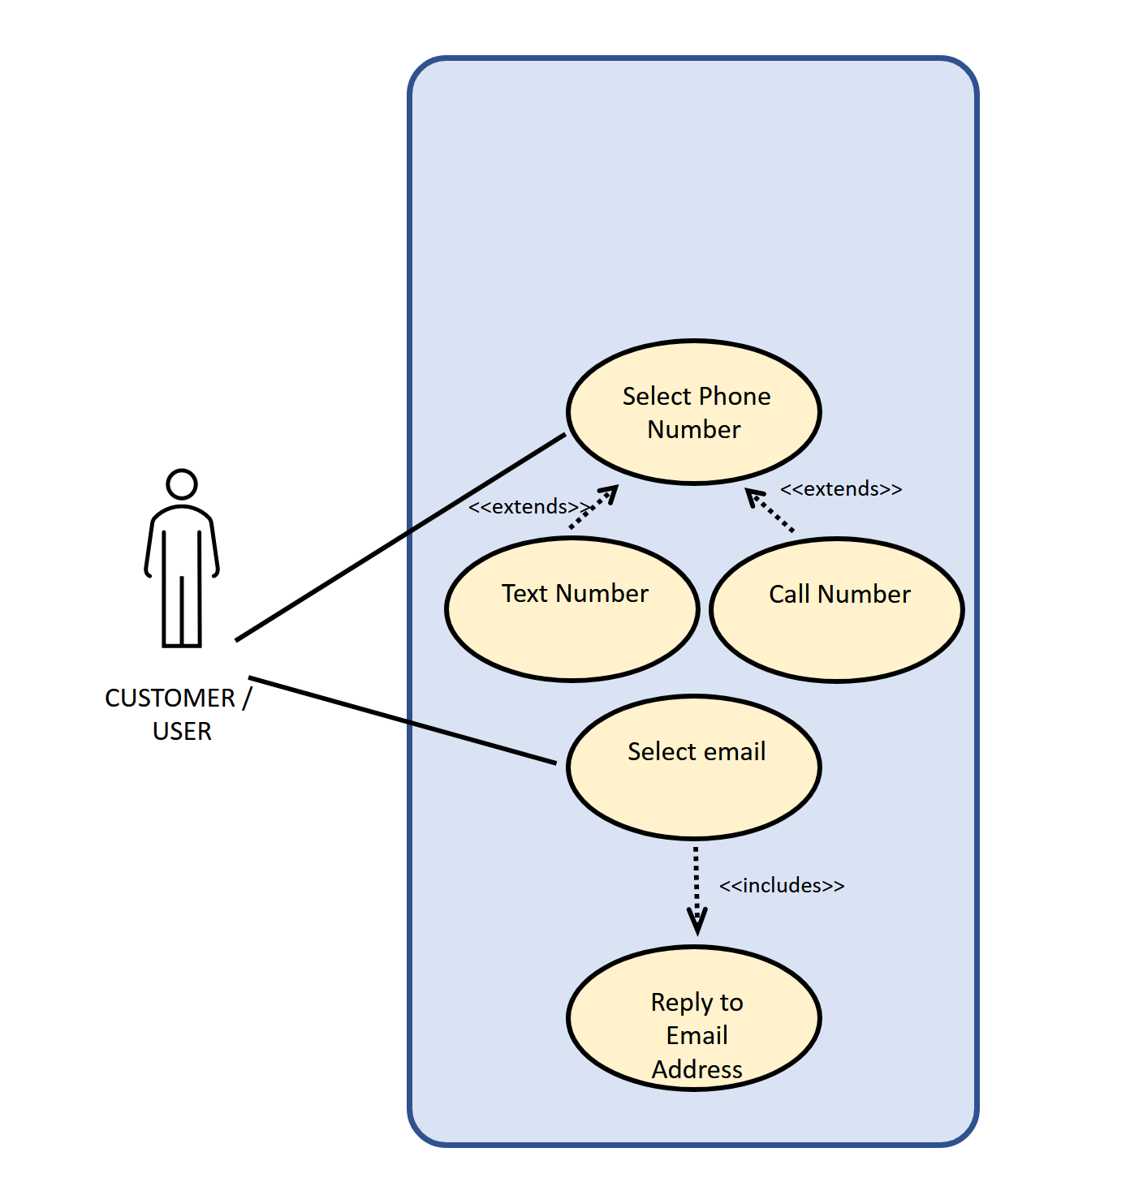

**Description:**

This Use Case diagram describes the functionality for allowing the application to call, text or email senders.s. It also allows users to select phone numbers and email addresses throughout emails and digests so the customer can call, text or email them. This will also leverage native phone functionality to open the email application, text application and dialer.

**Use Cases:**

* Call or text a phone number in an email or digest visually.
* Reply to an email address in an email or digest visually.

**Primary Actor:**

Customer – user of the application.

**Supporting Actors:**

None

**Stakeholders and Interests:**

The Customer

**Pre-Conditions:**

Customer has email loaded into the application.

* + **Post Conditions**The user will be able to call/text any phone numbers in an email or digest.
  + The user will be able to reply to any email addresses in an email or digest.

**Minimal Guarantee:**

The user will be able to call or text any phone numbers that happen to appear in an email or digest. They will also be able to reply to any email addresses in an email or digest.

**Main Success Scenario**

1. Customers can call any phone numbers that appear in the text of an email or digest.
2. Customers can text any phone numbers that appear in the text of an email or digest.
3. Customers can email any emails addresses that appear in the text of an email or digest.

## Assumptions and Dependencies

### Assumptions

* USPS will have a persistently available server capable of receiving collected application data.
* Users have access to an iOS or Android device capable of running the application.
* Users will provide their email username and password in order to access their account.
* Users will provide an account with the appropriate mail protocol enabled.
* Testing will be completed on both Android and iOS platforms to ensure cross platform functionality.

### Dependencies

* Project team available for start of this requirement implementation.

# Specific Requirements

The Use Case Reports below will provide the details of the 9 Use Cases being implemented with this application. The following Use Cases will contain both internal and external pre and post conditions.

## Use-Case Reports

### Use Case Name: Viewing Sender/Keyword Notifications List Visually

**Summary**: The Sender/Keyword Notification Feature allows the user to set up notifications when a specified sender sends mail to the user or the mail contains the specified keyword. Users must be able to see the list of senders/keywords that they are receiving notifications for via the graphical user interface.

**Preconditions**: The user must be logged into the application.

**Triggers**: The customer selects the “Notification Options” button

**Basic course of events (Scenario):**

Internal Precondition: The customer is logged into the application

| **Actor** | **System** | **Screen** |
| --- | --- | --- |
| 1. The user selects the Notifications button on the home page. |  |  |

| **Actor** | **System** | **Screen** |
| --- | --- | --- |
|  | 1. The System navigates the user to the Notifications Page. |  |
| 1. The user selects "Manage" |  |  |
|  | 1. The system navigates the user to the Manage Section of the Notifications Page |  |

**Post Condition:**

1. The user is on the Manage Section of the Notifications Page.

### Use Case Name: Adding Sender/Keyword to Notify for Visually

**Summary**: The Sender/Keyword Notification Feature allows the user to set up notifications when a specified sender sends mail to the user or an email arrives that contains a specified keyword. This allows the user to add a sender/keyword to notify visually.

**Preconditions**: The customer is on the sender notification screen.

**Triggers**: The customer selects the Add Sender or Keyword button on the Notification Options screen.

**Basic course of events (Scenario):**

**Internal Precondition:** None

| **Actor** | **System** | **Screen** |
| --- | --- | --- |
| 1. The customer selects the “Add”” button. |  |  |
|  | 1. The system pops up a a new entry. |  |

| **Actor** | **System** | **Screen** |
| --- | --- | --- |
| 1. The user enters a name or keyword and selects Save.. |  |  |
|  | 1. The name or keyword is added to the list. |  |

Inter Post Condition:

1. The name or keyword is added to the notifications list and the system will alert the user if a mail arrives with the specified sender/keyword.

**Alternate path:**

1. The user selects cancel.

Internal Precondition: Customer is logged into the application.

| **Actor** | **System** | **Screen** |
| --- | --- | --- |
| 3. The user selects cancel. |  |  |
|  | 4. The System closes the entry. |  |

**Inter Post Condition:**

1. Nothing is added to the notification list.

**Post Conditions:**

None

### Use Case Name: Deleting Sender/Keyword to Notify for Visually

**Summary**: The Sender Notification Feature allows the user to set up notifications when a specified sender sends mail to the user or an email arrives that contains a specified keyword. The user must be allowed to delete the senders\keywords that are being notified for visually.

**Preconditions**: The user must be logged into the application

**Triggers**: The customer selects the clear button on a sender\keyword in the list.

**Basic course of events (Scenario):**

Internal Precondition: The customer is on the notification options screen.

| **Actor** | **System** | **Screen** |
| --- | --- | --- |
| 1. The customer selects the clear button on a sender name or keyword in the list. |  |  |
|  | 1. The system deletes the entry. |  |

**Post Conditions:**

1. The name/keyword is deleted from the list and the system will not alert the user if mail comes in with the deleted sender or keyword.

### Use Case Name: Receiving Sender/Keyword Notifications

**Summary**: The Sender Notification Feature allows the user to set up notifications that use a text string as notification triggers on information contained on the physical mail piece image (primary objective), or email sender address (secondary objective), or email body (tertiary objective). The application shall create a push notification when email is retrieved, images are processed with Google Vision API, and an alert able text string is detected in one of the scanned fields. Additionally, an in-app alert will also be created and will be available for the user the next time the app is opened.

**Preconditions**: None

**Triggers**: An email is received which has initiated a trigger has a listed sender name/keyword in the sender/subject/body of the mail message.

**Basic course of events (Scenario):**

Internal Precondition: None

|  |  |  |
| --- | --- | --- |
| **Actor** | **System** | **Screen** |
| 1. An email is received that contains a flagged keyword in either a scanned physical mail image, sender’s address, or the messages body. |  |  |
|  | 1. The system generates a push notification for that message. |  |
|  | 1. An in-app notification is generated and saved to the notification center which mirrors the push notification. |  |
| 1. The user selects the push notification. |  |  |
|  | 1. The system opens the application and the referenced email message. |  |

**Alternate path:**

1. The application is already open

|  |  |  |
| --- | --- | --- |
| **Actor** | **System** | **Screen** |
| 1. The user taps on the in-app notification. |  |  |
|  | 1. The system opens the referenced email message. |  |

**Post Condition**:

None

### Use Case Name: Sending Barcode and Link Data to USPS

**Summary**: The customer needs the ability to get data on which barcodes and links are clicked on in the mail messages to better understand what their users are actually viewing.

**Preconditions**: None.

**Triggers**: The user scans a barcode or selects a link.

**Basic course of events (Scenario):**

Internal Precondition: None

|  |  |
| --- | --- |
| **Actor** | **System** |
| 1. The user scans a barcode or selects a link |  |
|  | 1. The system gathers information about that barcode/link (The Mailer Identifier (MID)/ Serial Number, timestamp, action info) and sends it to an API. |

**Post Condition**:

Data about the link/barcode is sent to USPS for processing.

### Use Case Name: Track and Report Consumer Data

**Summary**: The application shall verify user consent to terms at time of installing the application. It shall track usage statistics for consumer research data to report to USPS.

**Preconditions**: The customer must have informed delivery and has installed the mobile application.

**Triggers**: After installing the application and opening it, the customer shall be presented with a link to USPS terms and conditions for using the application which includes allowing application tracking. After accepting, the application shall begin tracking user button clicks, screen time, and navigation paths.

**Basic course of events (Scenario):**

Internal Precondition: Customer has installed application.

| **Actor** | **System** |
| --- | --- |
|  | 1. Asks User to review and accept terms and conditions for application installation. |
| 1. User accepts terms and conditions. |  |
|  | 1. The system uses a flutter analytics library to passively collect data on consumer usage including screen time, button clicks, and navigation paths. |

**Post-condition:** Data is displayed in the metrics dashboard and can be optionally sent to USPS.

### Use Case Name: Open resulting mail piece from search

**Summary**: The application shall provide a way to navigate to the detailed mail piece view page from the search results page. It shall provide navigation options from that detailed page for returning to the search results page and navigating to the next and previous results.

**Preconditions**:

* The customer must have informed delivery and has installed the mobile application.
* There exists a search page that displays summary information for each email found in the search.
* The user customer has searched for criteria that matches at least one received email.

**Triggers**: After searching for email with criteria that match at least one email and the user is on the search page viewing the results.

**Basic course of events (Scenario):**

Internal Precondition: Customer is viewing the search results containing at least one email.

| **Actor** | **System** |
| --- | --- |
|  | 1. Displays the list of mailepieces for each item in the list. |
| 1. User clicks on the mail piece they want. |  |
|  | 1. System opens the detailed mail piece page for that mail piece. |
| 1. User clicks the Back button. |  |
|  | 1. System navigates back to the search results page. |

**Post-condition: None**.

### Use Case Name: Adding Senders to the Notification List via Personal Assistant

**Summary**: The customer needs to be able to use a personal assistant to add a sender that will notify the user if mail is received from that sender. The application shall provide a way for a personal assistant such as Siri and Google Assistant to add a sender to the notification list.

**Preconditions**: The application is installed.

**Triggers**: The user asks the personal assistant to add a given sender to the notifications list.

**Basic course of events (Scenario):**

Internal Precondition: None

| **Actor** | **System** |
| --- | --- |
| 1. The user asks the personal assistant to add a sender to the notifications list. |  |
|  | 1. The system adds the given user to the sender notifications list and navigates the user to that page. |

**Alternate path:**

1. The sender already exists in the sender notifications list.

Internal Precondition: None

|  |  |  |
| --- | --- | --- |
| **Actor** | **System** | **Screen** |
|  | 2. The system does not add the given keyword to the notifications list. |  |

**Post Condition:**

A user has been added to the notification list if successful, none if it has not.

### Use Case Name: Searching for Emails Via Personal Assistant

**Summary**: The customer needs to be able to search for emails via a personal assistant. The application shall provide a way for personal assistants to query for emails between via keyword..

**Preconditions**: The application is installed.

**Triggers**: The user asks the personal assistant to search for an email.

**Basic course of events (Scenario):**

Internal Precondition: None

|  |  |
| --- | --- |
| **Actor** | **System** |
| 1. The user asks the personal assistant to search for an email giving a specified and keyword. |  |
|  | 1. The system navigates the user to the search page for the given keywords. |

**Post Condition:**

None

### Use Case Name: Opening Daily Digest Via Personal Assistant

**Summary**: The customer needs to be able to open their daily digest via the personal assistant.

**Preconditions**: The application is installed.

**Triggers**: The user asks the personal assistant to open the daily digest.

**Basic course of events (Scenario):**

Internal Precondition: None

|  |  |
| --- | --- |
| **Actor** | **System** |
| 1. The user asks the personal assistant to open the daily digest. |  |
|  | 1. The system navigates the user to the daily digest page. |

Internal Postcondition: The user is on the daily digest page.

**Alternate path:**

1. There is no daily digest.

Internal Precondition: None

|  |  |
| --- | --- |
| **Actor** | **System** |
|  | 2. The system reads that there is no daily digest. |

Internal Postcondition: None

**Post Condition:**

None

### Use Case Name: Launching Application via Personal Assistant

**Summary**: The customer needs to be able to launch the application via the personal assistant. The application shall provide a way to launch the app if the user request it be launched via a personal assistant.

**Preconditions**: The application is installed.

**Triggers**: The user asks the personal assistant to launch the application

**Basic course of events (Scenario):**

Internal Precondition: None

|  |  |
| --- | --- |
| **Actor** | **System** |
| 1. The user asks the personal assistant to launch the application |  |
|  | 1. The system launches the application and it begins its normal startup procedures. |

**Post Condition:**

The application is launched.

|  |  |  |
| --- | --- | --- |
|  |  |  |
|  |  |  |
|  |  |  |

### Use Case Name: Call or text a phone number in an email or digest visually.

**Summary**: The application shall provide a way to call or text phone numbers that appear in emails or digest messages.

**Preconditions**: The user is in an email.

**Triggers**: The user clicks a phone number in an email or digest.

**Basic course of events (Scenario):**

Internal Precondition: None

|  |  |  |
| --- | --- | --- |
| **Actor** | **System** | **Screen** |
| 1. The user clicks a phone number in an email or digest. |  |  |
|  | 1. The application opens a dialog asking if the user would like to call or text the number |  |
| 1. The user selects “Call” |  |  |
|  | 1. The application opens the system phone with the number prepopulated. |  |

Internal Postcondition: The user is on the phone application for the given number.

**Alternate path:**

1. The user selects “Text”

Internal Precondition: None

|  |  |  |
| --- | --- | --- |
| **Actor** | **System** | **Screen** |
| 1. The user selects “Text” |  |  |
|  | 1. The application opens the system text application for the given number |  |

Internal Postcondition: The user is on the text application for the given number.

**Post Condition:**

None

### Use Case Name: Send an email to an email address in an email or digest visually.

**Summary**: The application shall provide a way to send emails to email addresses in an email or digest vocally.

**Preconditions**: The user is in an email.

**Triggers**: The user selects an email address in an email or digest.

**Basic course of events (Scenario):**

Internal Precondition: None

|  |  |  |
| --- | --- | --- |
| **Actor** | **System** | **Screen** |
| 1. The user selects an email address in the email |  |  |
|  | 1. The application opens up the system email application for the specified address. |  |

**Post Condition:**

The user is in the system email application for the given email address.

### Use Case Name: Display links as clickable hyperlinks in retrieved email/digest

**Summary**: The application shall provide a way for all hyperlinks to be displayed as links in the retrieved email and digest.

**Preconditions**: The user is in an email or digest.

**Triggers**: The user opens mail with links.

**Basic course of events (Scenario):**

Internal Precondition: None

|  |  |
| --- | --- |
| **Actor** | **System** |
| 1. The user opens mail with links. |  |
|  | 1. The application finds all links and converts them to clickable hyperlinks |
| 1. The user selects a hyperlink. |  |
|  | 1. The application opens the browser for the specified link/barcode. |

**Post Condition:**

The user is in the browser for the specified link.

### Use Case Name: Displaying barcodes or QR codes as clickable hyperlinks in email.

**Summary**: The application shall provide a way for all barcodes/QR codes that contain links to be displayed as links in the retrieved email and digest.

**Preconditions**: The user is in an email or digest.

**Triggers**: The user opens mail with links.

**Basic course of events (Scenario):**

Internal Precondition: None

|  |  |
| --- | --- |
| **Actor** | **System** |
| 1. The user opens mail with barcodes/QR codes |  |
|  | 1. The application finds all barcodes and QR codes and runs them through google vision to extract the URL. It then makes the barcode clickable. |
| 1. The user selects a barcode with a link. |  |
|  | 1. The application opens the browser for the specified link. |

Internal Postcondition: The user is in the browser for the specified link.

**Alternate path:**

1. The user selects a barcode without a link

Internal Precondition: None

|  |  |
| --- | --- |
| **Actor** | **System** |
| 1. The user selects a barcode without a link. |  |
|  | 2. The application does nothing. |

Internal Postcondition: None

**Post Condition:**

None

## Supplementary Requirements

There are no additional supplementary requirements required for this implementation.

## Non-functional Requirements

* 1. All features of the application will be compatible with the built in Android/iOS accessibility functions.
  2. The application will consist of both an iOS and Android application.
  3. All functionality in the original application must continue to work unless changes are approved by the customer.
  4. The application UI shall consist of easily selectable buttons to make it easier to use for users with visual impairment.
  5. All data will be stored in an encrypted database on the device to improve security of user data.
  6. All data will be encrypted in transit to protect customer information.
  7. The application shall be responsive, and all actions should be completed in under 1 second, excluding actions that may encounter network latency.

# Supporting Information

N/A

Appendix

|  |  |
| --- | --- |
| **Requirement** | |
|  |  |
|  |  |

Removed Requirements